**Coastal Carolina Council Conservation Weekend**

January 31- February 2, 2025

**Program Guide**

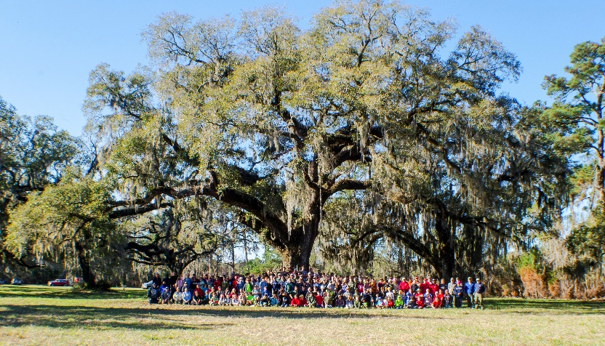

Tom Yawkey Wildlife Center

1 Yawkey Way South

Georgetown SC 29440

**Table of Contents**

|  |  |
| --- | --- |
| **What is the Conservation Weekend?...................................................................................** | **3** |
| **Registration.........................................................................................................................** | **4** |
| **Cost.....................................................................................................................................** | **4** |
| **Location…………………………………………………………………………………………………………………………….** | **4** |
| **Check In and Check Out.......................................................................................................** | **4** |
| **Safety and Medical..............................................................................................................** | **5** |
| **Tenting................................................................................................................................** | **5** |
| **Meals..................................................................................................................................** | **6** |
| **Inclement Weather.............................................................................................................** | **6** |
| **Cancellations.......................................................................................................................** | **6** |
| **Rules of Conduct.................................................................................................................** | **7** |
| **Schedule.............................................................................................................................** | **8** |
| **Awards...............................................................................................................................** | **9** |
| **NOVA Awards…………………………………………………………………………………………………………………..** | **9** |
| **BSA World Conservation Award..........................................................................................** | **9** |
| **Merit Badges.......................................................................................................................** | **10** |
| **In Memory of Bob Joyner …………………………………………………………………………………………………** | **11** |
| **Directions and Maps............................................................................................................** | **12 - 13** |
| **Contact Information............................................................................................................** | **14** |

**What is the Conservation Weekend?**

The conservation weekend is an overnight camping event for Scouts BSA Scouts and leaders. The program includes merit badge courses with a focus on Environmental Science, Conservation, and Nature Stewardship.

We are offering merit badge courses on Saturday morning and Saturday afternoon, giving Scouts the opportunity to enroll in up to two (2) merit badge courses.

This year we will include a NOVA award *Let it Grow*.

The event also includes a three-hour long conservation service project on Sunday morning, which can be used towards service hours or the BSA World Conservation Award.

**\*Sunday Morning Conservation Project Details**

This year’s conservation project will be geared towards the threatened red cockaded woodpecker. We will be clearing brush under long leaf pines which is their habitat.

\***Please bring work gloves, loppers, hand cutters, hand saws, machetes for adults and any other tools that might assist in clearing small brush.** Share this information will all participants so we have enough tools on hand.

**Administrative Information**

**Registration**

All Scouts BSA registered Scouts are eligible to attend the Conservation Weekend. Non-scouting siblings, Cub Scouts, or other youth are not allowed to attend.

Units should provide at least two (2) registered and Youth Protection trained (YPT) adults. **Units** should register using mycampmanager.com.

Registration will be open between 12/2/24 and 01/24/25 No late registrations or walk-in registrations will be allowed.

**Cost**

Scout Registration - $20

Adult Registration - $15

All registered participants will receive a Conservation Weekend patch.

**Location**

Tom Yawkey, through his will, donated 20,000 acres of land on Winyah Bay in Georgetown, SC to the SC Wildlife and Marine Resources Department DNR and established the Yawkey Foundation to annually fund the maintenance of the property as a protected wildlife preserve in perpetuity. Over the years, Jean Yawkey added additional land to what is now known as the Tom Yawkey Wildlife Center. The 24,000-acre property remains dedicated to conservation, research, and educational purposes. We will be camping in a 20 acre field, surrounded by trees.

Directions and maps are at the end of the packet.

**Check In and Check Out-Please read and share this information with your unit as it is highly important!!**

*Scouts should arrive with their units on Friday, January 31st between the hours of 4pm and 6:30pm. If a Scout is being dropped off please arrange for a ride on to island, if a parent must drive the Scout in they have to be off island no later than 6:30.*

*Check out will be at 12:00pm Sunday. Our departure is dependent on the tides, which we have carefully scrutinized. If you absolutely have to depart sooner, plan on leaving your vehicle in the boat landing parking lot. Transportation to and from the facility will be the responsibility of the unit or the scout’s parents or guardians.*

*In order to get to the Wildlife Center, a swing bridge must be put into place to allow access. Please park in the parking areas as directed. Check-In will be located on island. Troop trailers are welcome in camping areas; however they tend to hold up the bridge crossing as we have to wait for a lower tide, if you can pack gear in larger vehicles this would be preferred. Smaller cars can get stuck on the road to camp so take this in mind as well. Carpooling is highly encouraged.*

Please have the following items for check in:

* Annual Health and Medical Forms (A&B) for each scout and adult
* Completed prerequisite forms for each scout

The weekend should conclude around 11:30am on Sunday. Have all gear packed up after breakfast and before the service project. Please clean up your camping areas before vacating the Wildlife Preserve. As the bridge must be put in place to allow vehicles on and off the island, leaving early will be difficult. Please plan on staying the full duration of the program.

All scouts must leave with their parent, guardian, leader, or an individual approved by the parent or guardian.

**Safety and Medical**

We will have a trained medic on site for immediate medical needs. Every scout and leader must have a completed health form upon arrival. Copies of this form can be downloaded from the BSA website at [www.scouting.org](http://www.scouting.org).

If a scout has a medical need requiring accommodation to the program, please contact the Program Director, Michelle Strobel, to discuss alternative needs.

In the event of an illness or emergency, every reasonable effort will be made to ensure the safety of all scouts and leaders.

**Tenting**

The tent area is a large wooded area surrounding a center field. Each participant will need to bring their own tent or hammock. We will attempt to accommodate units to pitch their tents together. Campsites will be pitched in a “first come, first served” basis. Please be mindful when establishing camping sites that we will have many participants in the area.

Units may have individual campfires at their sites as long as they follow the Leave No Trace principles of fire.

**Meals**

Each unit is responsible for the planning, storage, and preparation of their own meals. Units should bring their own cooking equipment and eating utensils. Mealtimes are posted on the schedule. Sunday departure may be after lunch, you may want to have easy access to lunch items.

Each scout/unit should have a water bottle and bring water with them. **Non-potable water** will be available for use on site, which will have to be boiled prior to drinking. It is recommended that you bring some drinkable water as well.

**Inclement Weather**

This is a rain or shine event. Please dress and pack gear according to the weather.

**Cancellations**

Cancellation must be in writing. Cancellations prior to 01/23/25 will receive a 90% refund of the registration fee. No refunds will be given if a cancelation is requested after 1/24/25.

Substitutions are not allowed. If you wish to add a participant, please add the attendee, and submit a registration for the new participant. Fees applied will be based on the registration date.

No shows or registrants who do not submit a written explanation for cancellations will not be eligible for a refund. Refunds cannot be deferred or transferred to other programs.

**Rules of Conduct**

* All Scouts and adults are expected to live by the principles of the Scout Oath, the Scout Law, and the Outdoor Code while attending the Conservation Weekend.
* The buddy system must be used at all times.
* Two deep leadership must be observed at all times.
* Practice Leave No Trace Principles wherever you go.
* All scouts should remain in designated areas at all times. Because Yawkey Wildlife Preserve is home to state and federally threatened animals, please stay out of closed areas. Human disturbance is detrimental to beach nesting birds.
* Prohibited items include firearms, ammunition, fireworks, alcoholic beverages, and tobacco products.
* No pets are allowed at any Scouting event. Dogs are prohibited on Yawkey Wildlife Preserve at all times.
* Staff reserves the right to take action, if necessary, including sending a scout home immediately who steals, vandalizes, possesses a controlled substance, or intentionally places themselves or another scout in danger. Please do not put staff in a position where difficult decisions like these need to be made.
* Scouts may wear class A or class B uniforms while attending merit badge classes and working on the conservation project. Scouts should arrive and wear class A uniforms to the Scout’s Own service on Sunday morning.
* **If your unit would like to volunteer for the following, please let Michelle know. Flags, Campfire MC, or Sunday Scout’s own.**

**Schedule**

|  |  |  |
| --- | --- | --- |
| Friday | | |
| Check In/Bridge Crossing | 5:00 – 7:00 pm | Follow signage |
| Unit Set Up | 5:00 – 8:00 pm | In Unit Campsite |
| Lights Out | 10:00 pm |  |
| Saturday | | |
| Reveille | 7:00 am |  |
| Breakfast | 7:00 am – 7:45 am | In Unit Campsite |
| Flag Ceremony | 8:00 am | Activity Field |
| Merit Badge/Nova Session 1 | 8:45 am – 11:45 am | TBD |
| Lunch | 12:00 noon – 1:00 pm | In Unit Campsite |
| Siesta | 1:00 pm – 1:45 pm |  |
| Merit Badge/Nova Session 2 | 1:45 pm – 4:45 pm | TBD |
| Round Table Discussion | 1:45 pm – 2:10 | Under Oak Tree |
| Leave No Trace-Adult & Youth | 2:10 pm - Until |  |
| Retire Flags | 5:15 pm | Activity Field |
| Dinner | 5:30 pm – 7:30 pm | In Unit Campsite |
| Campfire Program | 7:30 pm | Group Fire Ring |
| Lights Out | 10:00 pm |  |
| Sunday | | |
| Reveille | 7:00 am |  |
| Breakfast | 7:00 am – 8:00 am | In Unit Campsite |
| Scouts Own | 8:00 am – 8:20 am | In Camp |
| Service Project | 9:00 am – 12:00 pm | Long leaf pine |
| Depart Island/tide dependent | 12:00 – 2:00 pm | Eat lunch & wait for tides |

**Awards**

We have chosen our activities and merit badge offerings to help facilitate scouts to earn two different conservation focused awards. Not all scouts will complete all requirements for both of these awards over the weekend.

Units are responsible for finalizing and submitting the award applications for each registered scout. The purchasing of merit badges and awards is the responsibility of the unit.

**Scouts BSA World Conservation Award**

In order to obtain the **Scouts BSA World Conservation Award**, scouts must participate in a conservation project as part of an approved Scouting program totaling at least three (3) hours that addresses a conservation need common to more than one country and earn the following merit badges:

1. Environmental Science OR Sustainability
2. Soil and Water Conservation OR Fish and Wildlife Management
3. Citizenship in the World

**Merit Badges**

The selection of the merit badge offerings for this weekend are to help each Scout earn the conservation focused awards.

Each merit badge offered during the weekend may have prerequisites that must be completed before the weekend to receive a completion. Requirements will not be changed because of circumstances out of the Camp Director’s control. A partial completion will be issued if all requirements cannot be met during the weekend. Only those Scouts who pay attention and participate during the merit badge classes will receive credit for the merit badge.

For all merit badges, it is highly recommended that you purchase and read the merit badge pamphlet before the workshop.

At registration, scouts can choose one (1) merit badge for the Saturday morning session and one (1) merit badge for the Saturday afternoon session.

**NOVA Let it Grow**

This class only allows a max of 8 scouts, we will offer 2 classes in session 1 and session 2.

ALL Prerequisites for this award MUST be completed prior to the weekend. Plan on sharing your worksheets with the counselor. Class time will be going over your worksheets and in depth discussions. The following is what I will be looking for, among others:



1. (choose one - A, B, or C) Watching shows or documentaries, or reading books and being prepared to discuss the questions or ideas generated.

2. Earn one merit badge from the list and be prepared to discuss how it is related to agriculture.

3. If A is selected, have your Scout Master, or his/her assistant, or parent/guardian help you in the selection of the two topics. If B is selected, research two of the questions. If C is selected, choose an "agriscience" experiment that you are able to have results prior to the campout.

4. This requirement should be accomplished with either a parent/guardian or the scout's Scout Master or his/her assistant prior to camp.

|  |  |  |  |
| --- | --- | --- | --- |
| Class | Session 1 | Session 2 | Prerequisite(s) |
| Environmental Science Shawn J | X |  | Requirement 3.e 1&2  And req 5 |
| Photography Mindy T | X |  | Requirement 1b & 8 |
| Fish and Wildlife Mgmt. Bill Lewis | X |  | Requirement 5 |
| Bird Study Jennifer W |  | X | Requirement 9 |
| Soil and Water Conservation Bill L |  | X | Requirement 7e |
| Nature Sean S |  | X | Requirement 4-2 |
| NOVA Let it Grow  Dr. Stephen Cofer-Shabica | X | X | Requirements 1-4 with exception of “Discuss w/ counselor” |
| NOVA Let it Grow  Kim Robbins | X | X | Same as above |
|  |  |  |  |
|  |  |  |  |

The Conservation weekend is now held in Boy Joyner’s Memory

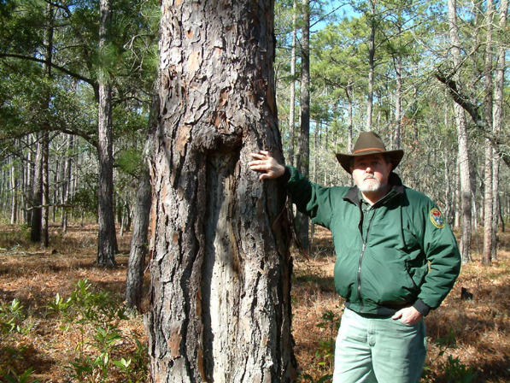Mr. Robert Lewis “Bob” Joyner Sr., 80, passed into eternal rest on Sunday, April 30, 2023, at home surrounded by his loving family.

Bob was born on June 14, 1942, in Spartanburg, SC son of the late Edgar Devineau Joyner and Vara Elizabeth Joyner of Winnsboro, SC. Bob was an avid outdoorsman as a young man which led him to pursue his dream career in Wildlife Management. He earned his Bachelor of Science in Biology and Botany from Wofford College in 1964 and his Master of Science in Wildlife Conservation from Virginia Tech University in 1966. Bob worked for the South Carolina Department of Natural Resources for 41 years with the highlight being his 30 years as Resident Biologist and Manager of the Tom Yawkey Wildlife Center in Georgetown, SC. Some in the public may have enjoyed one of the periodic field trips on the Island where he regaled visitors with stories of the history and magnificent beauty of the place where he worked and will forever consider home. Following retirement Bob worked on the advisory board as adjunct professor for Horry-Georgetown Technical College developing a Wildlife Management curriculum to add to the existing Forestry Program.

Mr. Joyner was actively involved with The Boy Scouts of America, having obtained the rank of Eagle Scout at age 16. He continued his devotion to Scouting serving as Eagle Scout Candidate Counselor for the Black River District for twenty years. Bob was also active with the following organizations: The Audubon Society, Ducks Unlimited, Operation Migration, The United Nations Biosphere Reserves, The Coastal Conservation League, and Winyah Indigo Society.

**Directions**

Tom Yawkey Wildlife Center Heritage Preserve

1 Yawkey Way S

Georgetown, SC 29440

Latitude: 33.23 Longitude:-79.222

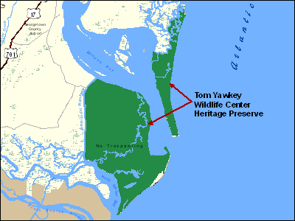

**From Georgetown:**

Travel south on US Hwy 17 over the Sampit River via the Sylvan Rosen Bridge. After crossing the bridge, proceed about 1/4 mile and turn left onto South Island Road (This turn is similar to a fork in the road & you will be turning just before you reach the gas station). Travel South Island Road for about 8 miles. The road will dead end at the South Island boat landing.

**From Charleston:**

Travel north on US Hwy 17 until you cross the North Santee River. Shortly after crossing the river, turn right on North Santee River Road. Proceed on North Santee River Road until it dead ends at Estherville Road. The only option will be to turn left on Estherville Road. Travel Estherville Road until you reach a stop sign. Turn right at the stop sign onto South Island Road. Proceed until the road dead ends at the South Island boat landing.

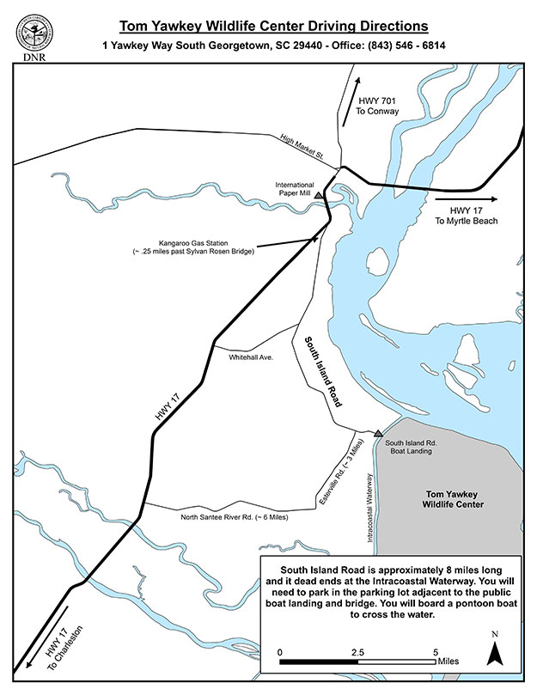

**Contact Information**

Michelle Strobel: Program Coordinator

[Michelle.strobel@scouting.org](mailto:Michelle.strobel@scouting.org)

Coastal Carolina Council

9297 Medical Plaza Drive

 N. Charleston, SC 29406

Mobile: 843-425-2351

[www.coastalcarolinabsa.org](http://www.coastalcarolinabsa.org)

Registration

[www.mycampmanager.com](http://www.mycampmanager.com)

Contact Information

Michelle Strobel 843-425-2351

Medic-Howard Hunter 843-475-1920

Yawkey Office – 843-546-6814