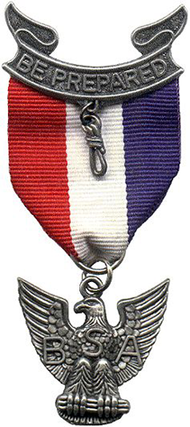
Coastal Carolina Council
You are cordially invited
To the
2025 Council Recognition Banquet & GATHERING of EAGLES
***Join us for this Special Night! ***
As we recognize you, the CLASS OF 2024 EAGLES.
We will also announce our newest SILVER BEAVER award recipients.
Other recognitions include
District Awards of Merit,
Veteran Pins, 2024 Eagle Scout Honoree,
NOESA Outstanding Eagle Scout Award.

Sunday, February 23rd, 2025
Elk’s Lodge 1113 Sam Rittenberg Blvd., Charleston, SC 29407
5:45PM Registration
6:30PM Program & Dinner.

2024 Eagles are FREE
All family members are welcome to join the fun @ $25 per person.
ADVANCED RESERVATIONS AND PAYMENT REQUIRED BY
FEBRUARY 7, 2025
Plaques are being made for each Eagle in attendance, so timeliness is important
Please email 3-5 photos of your Eagle Project and/or Ceremony to Michelle.strobel@scouting.org

Name____________________________ Eagle Name if Applicable_________________

E- Mail_________________________________ Phone ________________________

I would like to sponsor an Eagle Scout $________

No. attending __________ X $25 (2024 Eagles FREE) = $____________Amount Enclosed
Circle if applies
Must be received by 2/7/25: Coastal Carolina Council, BSA
9297 Medical Plaza Dr., N. Charleston, SC 29406
Phone: 843-763-0305
Register online www.coastalcarolinacouncil.org or Mycampmanager.com

__ __ __ __-__ __ __ __-__ __ __ __-__ __ __ __ exp ___ /___ cvv __ __ __ Signature__________________________

