Coastal Carolina Council

Presents

Cub Family Campout

At Camp Ho Non Wah

September 27-29, 2024

Welcome:

The Coastal Carolina Council welcomes you and your Cub Scouts to join us on the shores of the Bohicket for Cub Scout Family Camp on September 27-29, 2024.

We hope that your experience during this Cub Family Weekend will be filled with excitement and fellowship, and you can build great memories for yourself, your Scouts and family.

As you read this guide, you will find all the information you need to make the weekend a success. Should you have any additional questions or concerns not addressed in this document, please feel free to contact us at the council service center at 843-763-0305 or [550coastal.carolina@scouting.org](mailto:550coastal.carolina@scouting.org)

# Event Registration:

The Cub Scout Family Camp for the Coastal Carolina Council will be held at Camp Ho Non Wah located at 2609 Boy Scout Road, Wadmalaw Island, SC 29487

# Cost & Dates

Registration $45.00

Registration for the Cub Family event is now open.<mycampmanager.com/hnw/events/N410N5> Registration will be done through our camp registration program MyCampManager.com. We offer tutorials on the [council](https://www.coastalcarolinabsa.org/myCampManagerTut) [website](https://www.coastalcarolinabsa.org/myCampManagerTut) on the use of myCamp Manager, however, should you have any problems, please do not hesitate to contact the Council Office for assistance with registration.

**NO ONSITE REGISTRATION WILL BE ACCEPTED.**

Payment options include paying through our registration portal at myCampManager or by check through the council office. Credit Card payments are subject to a 5% convenience fee either through myCampmanager or the council office. Checks can be mailed to the council office at:

Coastal Carolina Council Attn: Cub Family Campout 9297 Medical Plaza Drive

N. Charleston, SC 29406

# Refund Policy

All refund requests must be submitted to the council service center in writing by the family. Any refund request received after the Monday prior to the event will be subject to a $20.00 program fee retained. Requests for refunds received after the event will not be considered.

Example circumstances under which refunds will be granted are listed below. Other requests may be honored with explanation.

* Illness of the scout prevented attendance.
* Illness or death in the scout’s immediate family prevents their attendance. Cancelation and refunds will be handled on a case-by-case basis.

# What to Bring to Camp

Other than some basic camping items, different families and packs bring different items with them. A good exercise is to think about your perfect weekend at camp and bring the items that you see in your mental picture.

What you bring to camp is what will keep you comfortable. You need enough changes of clothing to keep you clean. We will have changes in weather … hot, cold, and rainy!

To help keep you from forgetting those all-important items, we have a list below to help you when you are packing for camp.

Bring bug spray. This is the time of year NoSeeUms are out in abundance.

# The Basics

* Medical Forms Part A & B
* Tent (3-person tent is recommended for an Adult Partner and Cub Scout with gear/6-8-person tent is recommended for a family with gear.)
* Personal sleeping items – sleeping bag, pillow, bedroll, air pad
* Personal hygiene items – soap, towel, toothbrush, toothpaste, brush, comb, etc.
* Personal Medication
* Complete Change of clothes
* Rain Gear
* Extra Shoes
* Bug Spray
* Flashlight and Lantern
* Scout Uniform (for Scout’s Own Service)
* Camp Chair
* Cell Phone
* Water Bottle
* Closed Toe Shoes (to be worn at all times)
* Money for Trading Post
* Wagon to help get gear to the campsite.

Items to leave in your car or at home – while you are camping, unplug and enjoy the outdoors.

* MP3 players
* Video Games
* iPod/iPad
* Any other electronic devices

# Check In Procedures

Parents and/or Units should plan to arrive during registration times. The Camp Gate will not open early. Our staff needs time to make sure everything is ready to go for an exciting event.

Check-In Time – Friday, September 27, 2024 – 5:30 – 7:30 pm

Upon arrival at Camp Ho Non Wah you will need to check in on the porch of the Newberry Ecology Lodge located across from the parking lot. Finalized schedules and campsite assignments will be given out during registration. BSA Health and Medical Records will need to be turned in at check-in. All forms can be uploaded through the myCampManager. **Please complete these forms prior to coming to camp.**

# Campsites

All campsites are equipped with a picnic shelter, flush toilets, and hot water showers. There is NO electricity in any of our sites. If you require electricity for a c-pap machine, please plan accordingly and bring a battery-operated unit.

# Camp Trading Post

Our camp trading post is fully stocked with t-shirts, camp souvenirs, camping supplies, snacks, drinks and much, much more. Stop in and see us Saturday. The trading post is equipped to take all forms of payment.

# Health Lodge

The camp provides a trained medical officer on the premises and a physician on call 24 hours a day for emergencies. Please note that the adult leader/parent should provide basic first aid (band aids, mole skin, etc.) to campers.

Arrangements are made with St. Francis Hospital to treat emergency patients from camp. Transportation to St. Francis Hospital will be made on an emergency basis by Charleston County EMS. For injuries of a non-emergency nature, transportation should be provided by or of the unit leaders or parents to St. Francis as determined by the medic.

# Emergency Procedures

Written procedures are established for fires, lost scouts, lost bathers and severe storms or other emergencies. The Red Bell on our Parade Field is our emergency signal and will only be rung in the event of an emergency. Scouts, leaders, and parents need to report to the council ring when the Emergency Activation System is activated. Our staff will monitor the weather and will do everything possible to continue the program. The event coordinator or BSA professional should be notified immediately of all emergencies that occur while at camp.

# Directions to Camp

From Charleston, take US 17 South to Main Road. Turn left on Main Road and follow Main Road down to the 3rd traffic light. This is Maybank Highway. Turn right onto Maybank Highway and go over the bridge onto Wadmalaw Island. At the fork in the road, veer left. Once you pass the elementary school on your left you will have one more curve before the turn off to camp. Make a left onto Boy Scout Road and follow until you see the entrance to Camp Ho Non Wah. See you soon!

# Transportation

Cub Scout Camping Events at Ho Non Wah are family camping events. Each family is responsible for the safe transportation of its members to and from camp and to make sure that all vehicles meet national insurance standards. Please remember that transporting scouts or adults in the bed of an open pick-up truck or trailer – whether covered or uncovered – is against the policy of the Boy Scouts of America.

# Parking

Upon arrival at the camp, immediately park all vehicles in the parking lot in front of the camp office. Do not block the road. This road serves as a vital artery for camp logistics and two-way through passage must always be maintained. No exceptions. Overflow parking is across the road from our TRIBE Weekend Camping Area (Ecology Field.)

The camp has multiple hand carts for hauling gear from the parking lot to the campsites. To help facilitate the hauling of gear to your site you may want to bring your own wagon.

# Tips for Campers

The following are some tips that will help you while participating in a Cub Scout Family Camping Program.

* Be courteous to your other campers – do not cut through other campsites.
* Practice setting up and taking down your tent before coming to camp.
* Bring only what you need to spend the weekend. You will need to hike-in and hike-out your gear. Some families find it easier to bring a small wagon to help transport gear to your campsite.
* Follow your schedule to ensure all groups can do each activity.
* Camp wildlife likes your snacks. Please do not feed them or leave food in your tent. By doing so you are sending an open invitation for wildlife to come visit you.

# Meals

We strive to serve nutritious balanced meals during Family Camping Events. If you and your scout have special dietary requirements, we encourage you to bring any specialty foods that may be needed to supplement our regular meals. Such foods should be labeled with the individual’s name, and unit number. Refrigeration and heating will be available in the Dining Hall for these individuals.

Dietary/Special Needs forms are available on the progress bar at myCampManager.

# Check Out Procedures

We ask that all participants leave camp no later than 10:00 am Sunday. This will enable our staff to complete the necessary clean-up and sanitation of the camp.

Please practice Leave No Trace by cleaning your campsite before departing. After breaking down your campsite please carry any trash to our dumpster located behind the dining hall. When departing camp, please stop by the camp office and sign out.

# Annual Health and Medical Record

BSA Annual Health and Medical Record (most recent printing) are required for all attendees (including cub scout, parent, sibling, and leaders) at Cub Scout Camping Events of Coastal Carolina Council. **Only Parts A & B are required for events lasting less than 72 hours.** Medical forms must be turned in at registration and will not be returned at the end of the event. At the conclusion of the event med forms will be destroyed. Copies of this [form](https://filestore.scouting.org/filestore/HealthSafety/pdf/680-001_AB.pdf) can be downloaded from the council website.

# Insurance

All families and units must provide accident insurance for all family members attending this event. Parents/leaders must have their insurance information in case of an emergency. BSA Insurance applies after all other insurance has been utilized for participants injured at a Family Camping Event.

Medical expenses incurred by scouts, family members and leaders while in camp will be paid by the responsible party’s insurance and then the unit’s insurance. No fees will be billed to camp.

# Medication

Medications may be kept with the parent/guardian of the scout and dispensed as prescribed. Only refrigerated and injectable medications must be stored at the health lodge with the medical officer. Scouts and parents should bring their epi-pens and asthma inhalers.

# Schedule

Friday

5:30 pm – 7:30 pm Check-in and set up. **Dinner not served. Eat before arriving at camp**.

8:00 pm – Hang out at campsites

10:00 pm – Lights Out.

Saturday

7:00 am – Reveille

8:00 am – Breakfast @ Dining Hall

8:45 am – Opening Ceremonies @ Parade Field

9:00 am -Noon – Activities at your leisure

12:00 pm – Lunch @Dining Hall

1:30 pm – 5:00pm – Rotate through Activities

5:30 pm – Dinner @Dining Hall

7:00 pm – Campfire: songs, skits, and showmanship

8:30 pm – Cracker barrel

10:00 pm – Lights Out.

Sunday

8:00 am – Grab and Go Breakfast – Dining Hall Front Porch

8:30 am – Scouts Own at the Camp Chapel

9:00 am – Break camp & safe journey home

# Program Activities

Some of the activities being offered at the Cub Family Camp:

* Arrive and check-in, Meet the patrol leaders for each campsite.
* Showmanship, songs, and skits at Saturday night campfire.
* Cracker barrel
* Flag ceremonies
* BB’s and Archery
* Gaga Ball fun
* Fishing (bring your own gear/bait) not a rotation station
* Wrist rockets
* Canoes
* STEM stations
* Crafts

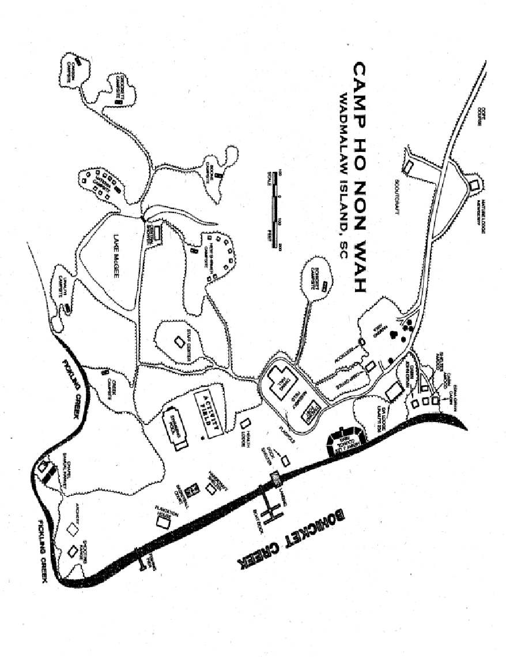

# Camp Rules and Regulations

We are all, first and foremost, members of the Boy Scouts of America. The basic rules governing Camp Ho Non Wah are the Scout Oath and Scout Law. We also ask that you follow the Outdoor Code. Rules are for your Scout’s safety, the protection of equipment and the preservation of fairness to everyone.

1. No personal vehicles are permitted in camp – all cars must be parked in designated parking areas outside the camp gate.
2. No pyrotechnics of any kind are permitted on camp property.
3. No alcoholic beverages or other unlawful drugs or substances are allowed in camp.
4. Closed-toed shoes must be worn at all times in camp.
5. No transporting passengers in the back of pick-up trucks is allowed.
6. Sheath knives are not allowed in camp. Bring approved folding pocketknives only.
7. Cooking in sites or in parking areas by individuals, families and packs is not permitted at this event.
8. Only refrigerated and injectable medications need to be stored in the Health Lodge.
9. The camp speed limit beings where the pavement ends. The speed limit in camp is 10 mph.
10. Leaving Camp – anyone leaving camp must first check out at the camp office.
11. Wildlife – Ho Non Wah is blessed with a wide variety of wild creatures. Under no circumstances should anyone touch or disturb snakes or other animals. Please educate Scouts on the identification of poisonous plants and animals indigenous to the Southeastern United States and review the Outdoor Code.
12. Respect of Privacy – Adult leaders must respect the privacy of youth members in situations such as changing into a swimming suit or taking showers. Adults must also protect their own privacy in similar situations.
13. Groups camping as a unit MUST HAVE TWO-DEEP LEADERSHIP – one-on- one counseling sessions between leaders and scouts are not allowed.
14. Separate Accommodations – Scouts are not permitted to sleep in a tent of an adult other than a parent or guardian.
15. Campfires – are permitted only in designated fire pits in each campsite with the approval of the camp office or camp ranger prior to burning. Campfires are NOT to be left unattended at any time.
16. All Scouts are responsible for the cleanliness of their campsite and for assisting in keeping the camp clean for others to enjoy.
17. Running after dark is not permitted.3