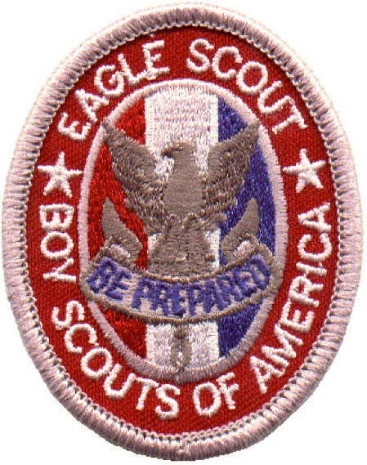
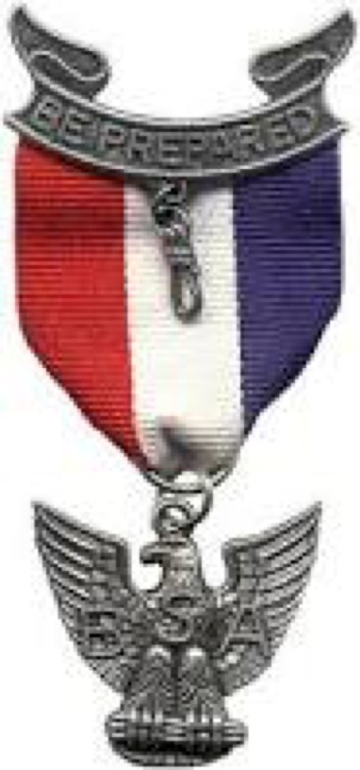
COASTAL CAROLINA COUNCIL
BOY SCOUTS OF AMERICA
9297 Medical Plaza Drive
N. Charleston, South Carolina 29406 Phone: (843) 763-0305

Congratulations!
Because of your dedication to the ideals of
Scouting, yet another scout stands ready to attain Scouting’s highest goal, that of Eagle Scout.
Enclosed in this packet is a copy of the instructions, internet links, and eagle counselors to give to the scout a Life to Eagle packet. Go over this with the candidate carefully. It would be a shame for them to reach this far and have one minor detail slip them up.
Also, in this packet is the letter requesting recommendations. Please print and sign each letter and make sure the scout has your correct address of the Scoutmaster on the envelope.
Again, please accept our congratulations. And thank you! Because of you, we continue to be able to serve the youth of the Lowcountry.
Coastal Carolina Council Advancement Committee
ONCE AN EAGLE, ALWAYS AN EAGLE

Trail to Eagle

Significance of the Eagle Scout Rank

The fact that a scout is an Eagle Scout has always carried with it a special significance, not only in Scouting but also as they enter higher education, business or industry, and community service. The award is a performance-based achievement whose standards have been well maintained over the years. Not every scout who joins a Boy Scout troop earns the Eagle Scout rank; only about 5 percent of all Boy Scouts do so. This represents more than 2 million Boy Scouts who have earned the rank since 1912. Nevertheless, the goals of Scouting—citizenship training, character development, and personal fitness— remain important for all Scouts, whether or not they attain the Eagle Scout rank.

Progression

To earn the Eagle Scout rank, the highest advancement rank in Scouting, a Boy Scout must fulfill requirements in the areas of leadership, service, and outdoor skills. Although many options are available to demonstrate proficiency in these areas, a number of specific skills are required to advance through the ranks—Scout rank, Tenderfoot, Second Class, First Class, Star, Life, and Eagle. To advance, a Boy Scout must pass specific tests that are organized by requirements and merit badges.

Merit Badges

Merit badges signify the mastery of certain outdoor skills, as well as helping scouts increase their skill in an area of personal interest. Of the 130+ merit badges available, 21 must be earned to qualify for Eagle Scout. Of this group, 13 badges are required, including First Aid, Citizenship in Society, Citizenship in the Community, Citizenship in the Nation, Citizenship in the World, Communications, Cooking, Environmental Science, Personal Fitness, Personal Management, Camping, and Family Life. In addition, a Scout has a choice between Emergency Preparedness and Lifesaving and a choice between Cycling, Hiking, and Swimming.

Scoutmaster Conferences

At each of his rank advancements, a Boy Scout takes part in a Scoutmaster conference. These conferences help the Scout to set goals for themselves in line with their individual talents and abilities. At each conference, the Scoutmaster helps them evaluate how well they accomplished their present goal and then works with the scout in setting new goals.

Service and Responsibility

Beginning with the Star rank, and continuing through Life and Eagle, a Scout must demonstrate participation in increasingly more responsible service projects. At these levels, they also must demonstrate leadership skills by holding one or more specific youth positions of responsibility in their patrol and/or troop.

Steps in Advancement

Advancement, one of the eight methods by which the aims of Scouting are achieved, has four steps through each award level.

First, the Scout learns. Much of the learning comes from other scouts in their patrol or troop and by active participation in troop program. Patrol activities are directed toward the skills they need. Every troop hike, camping trip, or other activity offers potential learning experiences. A Scout learns to pitch a tent by pitching one, to use a compass by finding directions, and to cook a meal by having to prepare and eat it.

Second, the Scout is tested. The specific requirements determine the kind of testing. Verbal testing is sufficient in some instances. In other instances, a Scout must demonstrate the skills by doing.

Third, the Scout is reviewed. The purpose of the review is to ensure that all requirements for advancement have been met. This includes a check of the Scout's attitude and practice of the ideals of Scouting, in addition to the Scout craft skills. The decision regarding whether a Scout has met the required standards to qualify for rank advancement begins with the troop and, for the Eagle Scout rank, is approved by the district, local council, and finally, the National Council.

Fourth, the Scout is recognized. The final step in advancement involves presentation of the badge, usually at a ceremony before the entire troop.

Boy Scouts with Disabilities

Boy Scouts with disabilities may qualify for the Eagle Scout rank. Each Scout must earn as many of the required merit badges as he can. The scout then submits an application for alternate merit badges. The BSA local council determines the alternate merit badges for them to earn.

Eagle Candidate Checklist

Congratulations! You are now ready to start the final stages on the Trail to Eagle, Scouting’s highest rank. In order to avoid unnecessary delay due to an incorrect procedure, this instruction sheet, along with Eagle Scout Application (link below) and Eagle Scout Workbook (link below) should be read THOROUGHLY.

DATE COMPLETED:

1. Read these instructions, the Eagle Scout Application, and the Workbook.

It cannot be stated too strongly that it is essential the instructions given here, on the application, in the workbook be read and followed in order. It would be a disaster to reach the final approval stage and realize that one little point, if not caught early, will keep you from attaining Eagle. Please contact the office (843) 763-0305 and request a person profile. This will help you fill out your Eagle Application with dates as well as verify all merit badges are recorded in the system.

2. Select and fill out your Project Proposal.

While a Life Scout, you must PLAN, DEVELOP, and GIVE LEADERSHIP to others in a service project helpful to any religious institution, any school, or your community. In the Project Proposal is an overview, but also the beginnings of the planning stages. Take some before photos of your project. This would be a good time to choose your Eagle Counselor from the list enclosed.

3. Get your Project Proposal Approved and Signed.

Your project proposal needs to be approved and signed first by the Beneficiary, then the Scoutmaster, next the Committee Chair, and finally an Eagle Counselor.

4. Do the project and fill out the Eagle Scout Service Project Final Plan.

Now you must finalize the details of your specific project. Record any changes from the proposal, the project phases, work processes, and materials etc. Be sure you have been recording all the hours you and others have spent on the project, not just the day of the project. Take photos of the final project.

5. Complete the Eagle Scout Application. Mail out requests for recommendations

Follow the directions listed on the application carefully. Dates and signatures must be obtained BEFORE you bring in the completed materials to the Council Office. Have your Scoutmaster sign the request for recommendation letters (link below). Put their name and address on the return envelopes and mail the requests to the references listed on your Eagle Scout Application. Begin writing your letter of ambition.

6. Participate in a Scoutmaster Conference.

Ask your Scoutmaster to review your project with you. He/she should have already reviewed your Eagle Application for completeness. Sign the Eagle Application and date it. Obtain the dated signatures of your Scoutmaster and Troop Committee Chairman.

7. Take the completed application, letter of ambition, and name of Eagle Counselor to the council office for signature.

This is the final check, the National Office, through your local council, must certify your application to be correct. Do not take the chance of having your application rejected!

DO NOT HAVE A BOARD OF REVIEW PRIOR TO CERTIFICATION BY THE COASTAL CAROLINA COUNCIL OFFICE!

8. Participate in an Eagle Board of Review.

The board of review for an Eagle candidate is composed of at least three but not more than six members. Your Eagle Counselor represents the Council / District and should be a part of the review board. A Council or District Representative must be in attendance and sign the advancement report. Unit leaders, assistant leaders, relatives, or guardians may not serve on the board. The board should convene 30 minutes before the candidate appears in order to review the application, life ambition statement, references, and project book. If the Eagle candidate is approved, the application and advancement form must be signed and dated by the Chairman of the Board of Review and the Council or District Representative.

9. Return the Eagle Scout Application and Advancement form to Council office.

Return the application to the council office for the Scout Executive’s signature. It will be forwarded to the National Office for the preparation of the Eagle Scout certificate. Your Scoutmaster will normally receive your Eagle Certificate between 2-3 weeks later.

10. Plan your Court of Honor.

There are some great resources available online or in the Scout Shop. Parents may want to visit http://www.usscouts.org/eagle/eaglecongrats.asp to request congratulatory letters form government officials. Also, if you would like a member of The Military Order of the World Wars to come out to your Eagle Court of Honor to make a special presentation, please contact Captain Frederick T. Massey, USN (Ret) at (843) 696-4994.

Congratulations! You can be justly proud of your accomplishment.

Guide to Advancement
Internet Links

http://www.scouting.org/filestore/pdf/33088.pdf

Eagle Scout Rank
http://www.scouting.org/scoutsource/GuideToAdvancement/EagleScoutRank.aspx

Eagle Scout Requirements http://www.scouting.org/scoutsource/BoyScouts/AdvancementandAwards/eagle. aspx

Application for Alternate Eagle Scout Rank Merit Badges
http://www.scouting.org/filestore/pdf/512-730.pdf

Eagle Scout Application
http://www.scouting.org/filestore/pdf/512-728_WB_fillable.pdf

Information for Project Beneficiaries
http://www.scouting.org/filestore/pdf/510-025.pdf

Eagle Project Workbook http://www.scouting.org/scoutsource/BoyScouts/AdvancementandAwards/Eagle WorkbookProcedures.aspx

Eagle Letter of Recommendation Request
http://www.coastalcarolinabsa.org/openrosters/DocDownload.aspx?id=86761

Board of Review Guide
http://www.coastalcarolinabsa.org/openrosters/DocDownload.aspx?id=143017

NESA Membership
http://www.kintera.org/site/c.9oIFJMPsGgIWF/b.9309361/k.BD8E/Home.htm

NESA Outstanding Eagle Scout Award
http://www.nesa.org/PDF/542-057_WB.pdf

National Society, Sons of the American Revolution
http://www.sar.org/Youth/Eagle_Scout

