Unali’Yi Lodge 236

Coastal Carolina Council, BSA

Congratulations on your selection as a candidate for membership in the Order of The Arrow. Your fellow scouts selected you to become a member of our Order. The Induction Weekend, previously called Ordeal weekend is a significant event in our Order, designed to test your dedication and commitment. It begins on Friday at 7:00 p.m. and concludes with the Sunday Morning General Lodge Meeting at 10:30 a.m. Participation in the entire weekend is required.

The Fall Induction is **September 13 -15, 2024**, at Camp Ho Non Wah, Wadmalaw Island.

You should arrive in your complete Field Uniform (Class A) and check in at the Trading Post Porch outside the Trading Post. Check-in is between 5:00–7:00 p.m. on Friday. Due to the structured nature of the Induction Weekend, anyone unable to be at camp by the close of registration may not be able to participate in the Induction Weekend. Please address any concerns about arrival or departure on the registration form.

The cost for the weekend is $60.00, which includes four meals, a cracker barrel, your dues for the current year, an Order of the Arrow Handbook, an Ordeal sash, and a Lodge pocket flap. This fee also covers the cost of the brotherhood sash they will be able to earn in 6 months following their induction. A small dinner will be provided on Friday night for all registered participants beginning at 6:00 p.m. in the Dining Hall. **Registration must be received by Monday, September 9th, 2024**, at the Council Office or via mail. After the election, Scouts, and adults remain candidates, until the Ordeal and Ordeal ceremony is completed. The candidate's name will be dropped if this candidacy period exceeds eighteen months. To become candidates again, they must be re-elected through the same process as the initial election, ensuring fairness and equal opportunity.

**What You Should Bring:**

Sleeping Bag, Ground Cloth & Tent Work Clothes and Gloves Water Bottle

Copy of Medical Form (Part A & B) Medication (if applicable) Toiletries/Towel

Small Flashlight, Poncho Money for Trading Post One Candle (Any Size)

Weekend Camping Gear Complete Scout Uniform Bug Spray

Before arriving at the Ordeal, you must carve a **small wooden arrow** to wear around your neck. The candle and Medical Form copy will need to be turned in at check-in. If you have any questions, special needs, or need more information, please do not hesitate to get in touch with me at Chief@site236.com or visit our website at [www.site236.com](http://www.site236.com). We are here to support you every step of the way. I eagerly look forward to meeting you and working with you as you embark on your journey as an Arrowman. Your selection for the Order of the Arrow is a testament to your dedication and we are excited to have you join us.

Yours in Brotherhood,

Mike McCready

Unali’Yi Lodge Chief

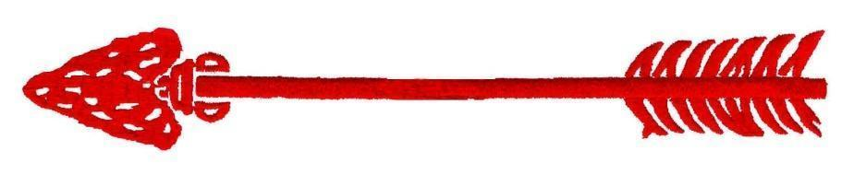

## Unali’Yi Lodge 236 – 2024 Fall Induction

September 13 – 15, 2024

Induction Candidate Registration Form

Name (Full): _________________________________________ Unit #: ____________

District: __________________ Date of Birth: _______________

Street Address __________________________________________________________

City: _______________________________ State: _________ Zip Code: ____________

Primary Phone: _________________________ Cell:_____________________________

(Please include both Home and good cell phone number)

Email Address: _________________________________

Check if Applicable:

____ LDS Scout/Scouter

____ Medical Concerns (Please specify) _______________________________________

____ All dietary concerns and restrictions should be emailed to [unaliyi.chief@gmail.com](mailto:unaliyi.chief@gmail.com)

| **Registration Type** | **Quantity** | **Item Cost** | **Item Total** |
| --- | --- | --- | --- |
| Ordeal Candidate* | ________ | $60.00 |  |

*Late Fee of $5.00 will be assessed on registrations received after Monday, September 9th.

Enclosed is the amount of $_________________.

Please make checks payable to BSA.

Mail to: Coastal Carolina Council, 9297 Medical Plaza Dr, North Charleston, SC 29406



**Parent Consent Form**

I hereby give my scout,__________________________, permission to attend the Fall Induction at Camp Ho Non Wah the weekend of September 13 – 15, 2024. They will stay at camp until departure on Sunday unless the Lodge Adviser is otherwise notified in writing prior to the function.

____________________________________ _____________________

Signature Date