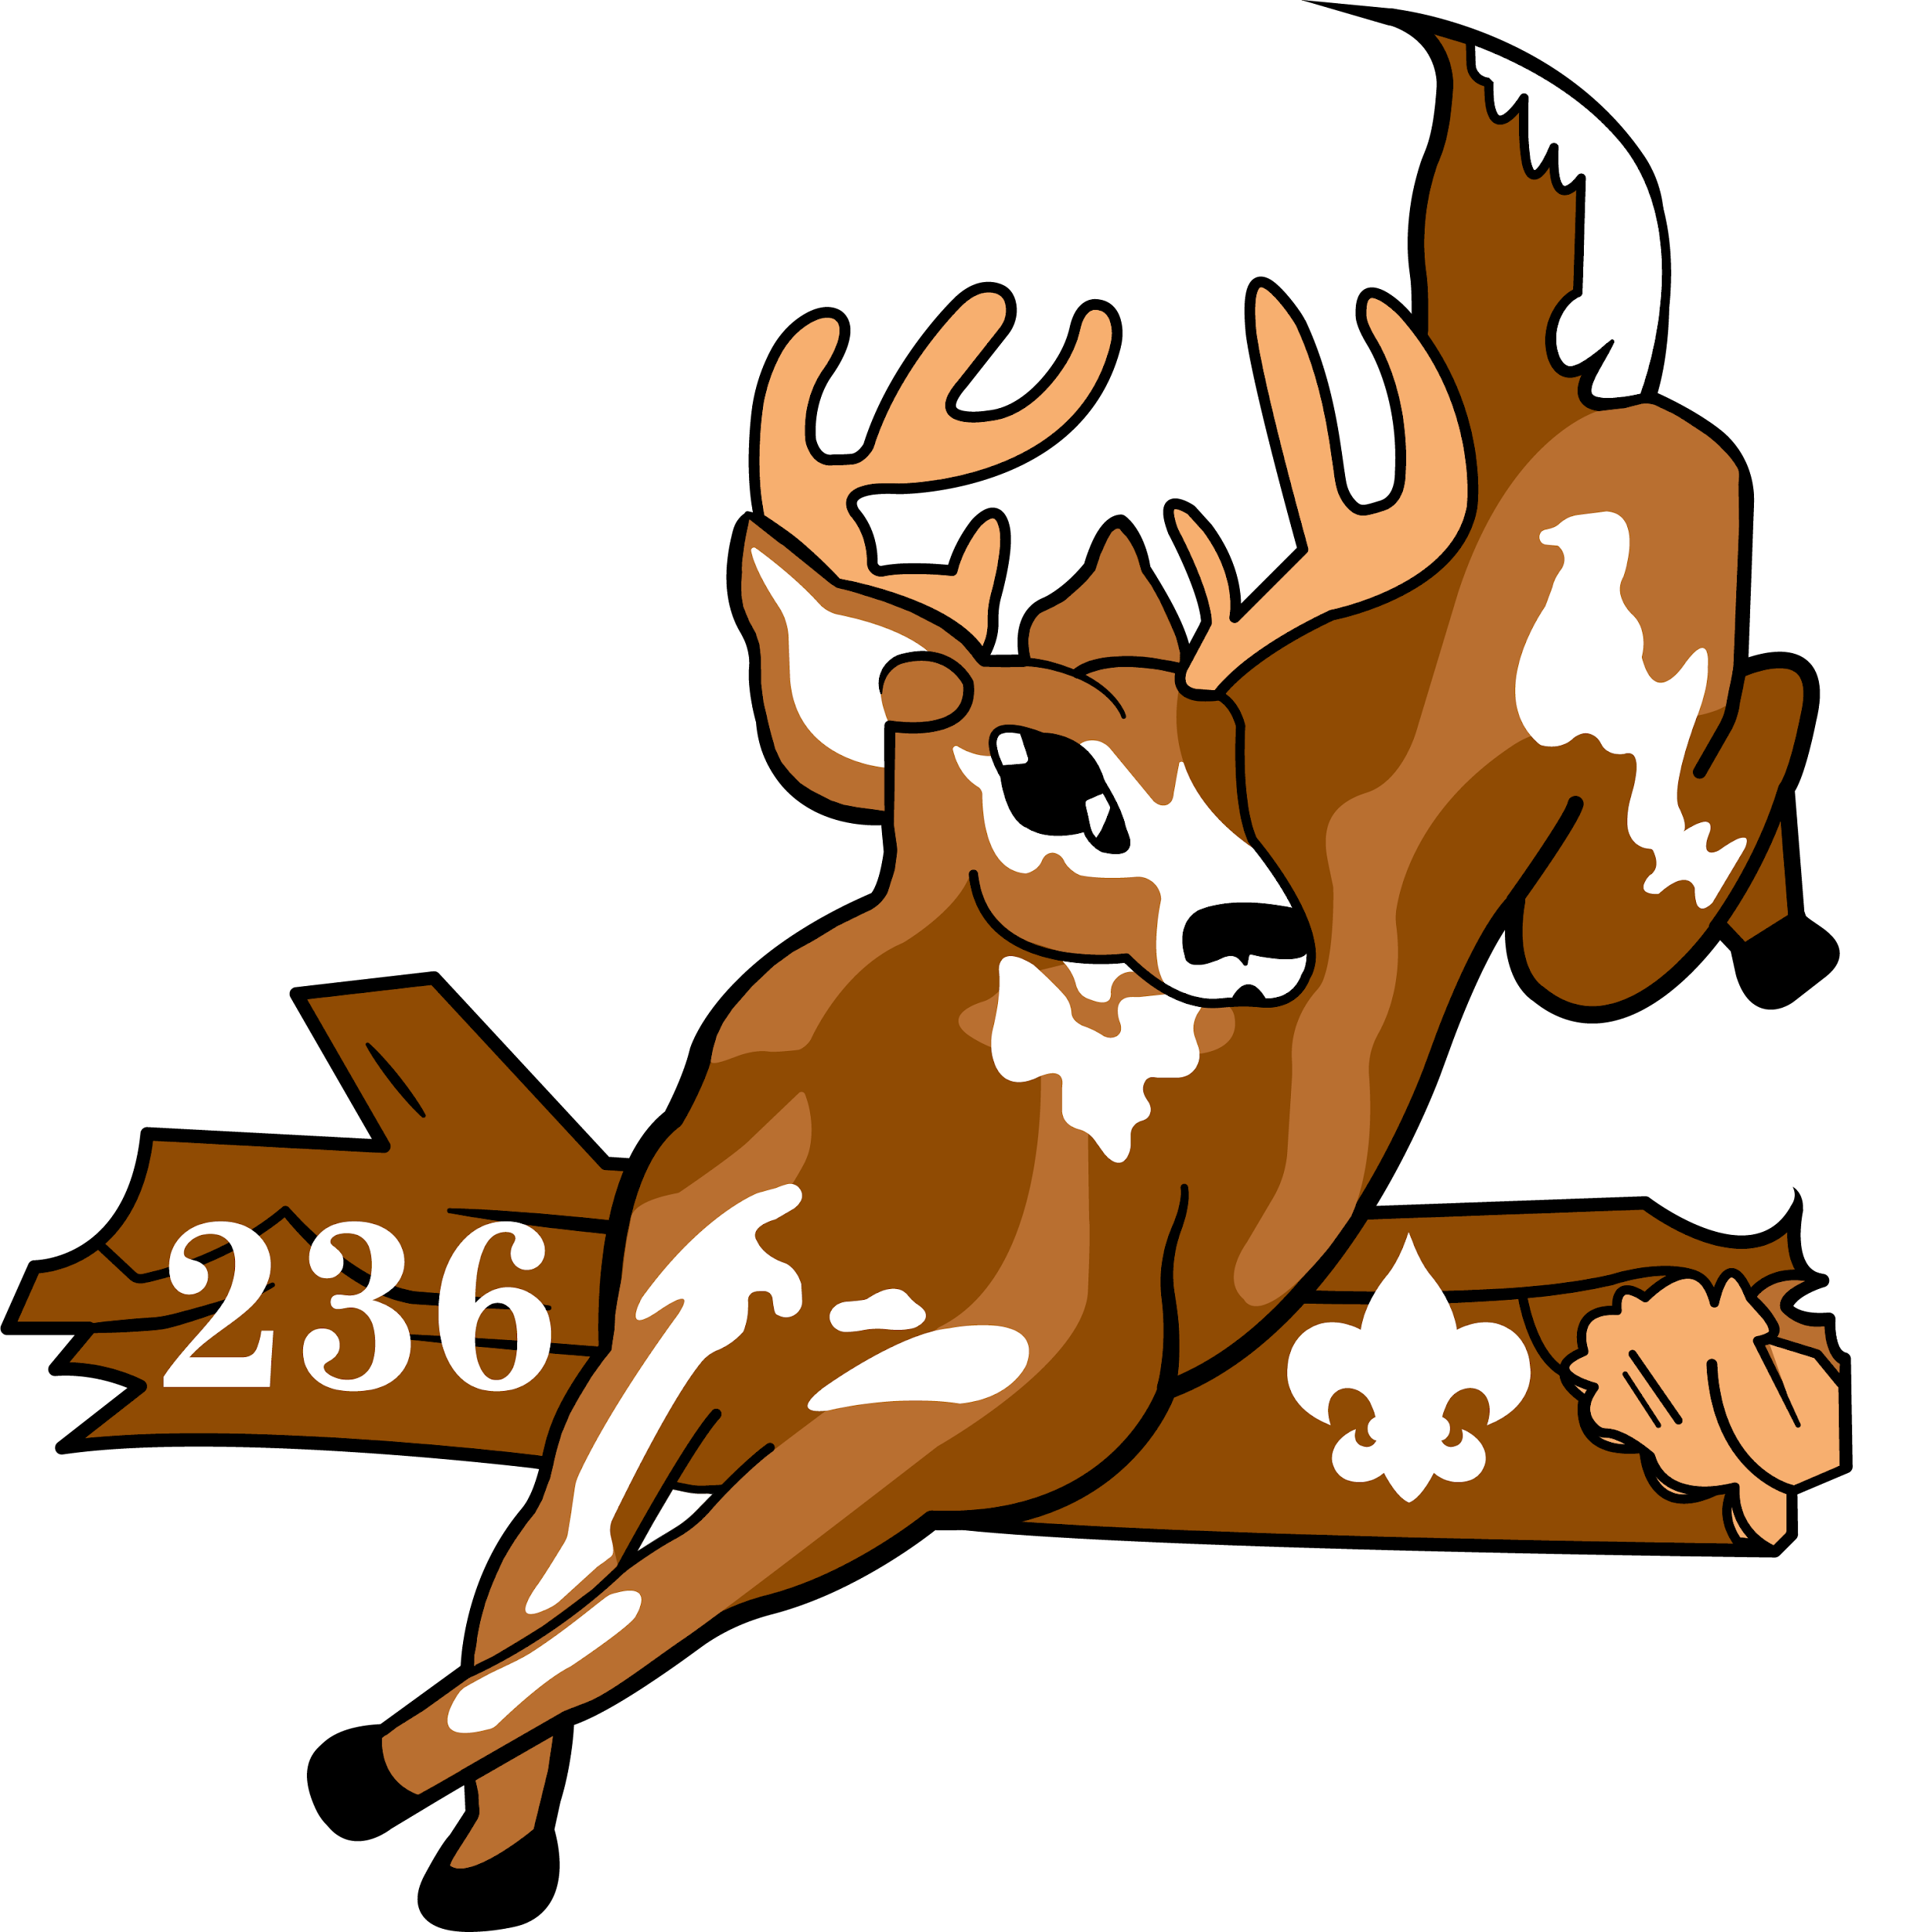

**Unali’Yi Lodge 2024 Fall Induction**

Dear Brothers,

I hope everyone is doing well. Our Fall Induction, a significant event for our lodge, is right around the corner! Our induction weekend will be held September 13-15 at Camp Ho Non Wah. Check-in for this function will be held in the Trading Post from 5:00-7:00 pm on Friday. Complete Field Uniform (Class A and OA Sash) is required for Friday Check-in and activities for the evening. Dinner will be served Friday at 6:00 pm for all registered members.

Be sure to bring the following items with you: tent, sleeping bag, work clothes, work gloves, water bottle, change of clothes, weekend camping gear, and a completed copy of Medical Form only Parts A & B. ***This form is required for participation in lodge activities and is crucial for us to ensure your safety and well-being during the event. Please turn it in at registration***. Look for additional tools needed for the induction in lodge e-blasts before the weekend. Please help us by being an example of cheerful service for those completing their induction by getting involved in work projects and lodge activities throughout the weekend!

Brothers, I want to stress the importance of the Early Bird deadline for **September 9**. Registering before this date not only secures your spot but also allows you to enjoy a discount on the lodge function fee. Online Registration will also be available on the council website. If there are brothers who did not receive this letter or registration form, please direct them to **Site236.com** for registration information. Let's not miss out on this opportunity to be part of a memorable weekend of service and camaraderie.

This weekend holds immense importance. It's the collective effort, of each and every one of us, that will transform our camp into a place of joy and learning for our campers. Remember, many hands make light work, and your contribution is invaluable. I urge you to join us and help make camp the best it can be. Let's come together as a community and create a weekend filled with camaraderie, service, and shared memories. I am excited to see you there, ready to make a difference! **The Best is Yet to Come!**

Yours in Service,

Mike McCready

Unali'yi 236 Lodge Chief

[Chief@site236.com](mailto:Chief@site236.com)

**Lodge Activity Attendance Policy**

All arrowmen attending for the weekend are required to be in camp until the completion of the event. All early departures should be discussed with our lodge adviser Wayne Barfield (843)-817-0084.

**Unali’Yi Lodge 236 – Fall Induction**

September 13-15, 2024

Lodge Member Registration Form

**PLEASE PRINT**

| **Youth/Adult** | **Name** | **Unit #** | **Ordeal**  **Brotherhood**  **Vigil** | **Chapter** |
| --- | --- | --- | --- | --- |
|  |  |  |  |  |
|  |  |  |  |  |
|  |  |  |  |  |

____ I will be sealing my membership and completing Brotherhood at this function

____ Medical Concerns (Please specify on the back of this registration from)

____ All dietary concerns and restrictions should be emailed to [unaliyi.chief@gmail.com](mailto:unaliyi.chief@gmail.com)

**Early Bird Registration (Prior to 9/9 ) Quantity Cost Total**

Lodge Member - Early Bird _______ $25.00 __________

**Member Registration (After 9/10 ) Quantity Cost Total**

Lodge Member _______ $30.00 __________

**2024 Lodge Dues - *ONLY IF NOT ALREADY PAID* Quantity Cost Total**

Lodge Member _______ $18.00 __________

**Total Amount Enclosed ________**

Please make checks payable to BSA.

Mail to: Coastal Carolina Council, 9297 Medical Plaza Drive, North Charleston SC 29406



**Parent Consent** I hereby give my Scout**,** __________________________, permission to attend the Fall Induction at Camp Ho Non Wah the weekend of September 13-15,2024. They will stay at camp until departure on Sunday, unless the Lodge Adviser is otherwise notified in writing prior to the function. _________________________________________________________Signature / Date

| **Lodge Leadership Development** 8/23-8/25 | **Fall Induction**  9/13-9/15 | **Cub Haunted**  10/25-10/27 | **Fall Fellowship**  12/6-12/8 |
| --- | --- | --- | --- |